
````````````````````````````````````````````````````````

A assignment on
Excel & Tableau
By Khondakar Tareq Ibne Abdullah

Table of Contents
Policies and Procedure 1
Why is it Important 2
Type chapter title (level 3) 3
Excel 4
Type chapter title (level 2) 5
Type chapter title (level 3) 6

When working with data like "The Wealth of Nations" (which could involve global economic data, country financial statistics, or other sensitive socio-economic indicators), it is essential to adhere to several data policies. These policies ensure that data is handled securely, ethically, and in compliance with legal frameworks. Here's an outline of the key policies and why they are necessary, along with the importance of being aware of these as a data analyst:

Key Policies to Adhere to When Working with Data:

1. Data Privacy Laws (GDPR, CCPA, etc.)
- What: Data privacy laws such as the General Data Protection Regulation (GDPR) in Europe and the California Consumer Privacy Act (CCPA) in the U.S. protect personal information by controlling how it is collected, stored, and shared.
- Why: These regulations are essential when working with data that contains personal or identifiable information (e.g., demographics, income data). They ensure that individual privacy is respected, and personal data is not misused or exposed.
- Importance for Data Analysts: Data analysts need to be aware of these laws to ensure compliance and to avoid severe penalties. Mishandling personal data can lead to legal consequences, including fines and reputational damage to the organization. As an analyst, it is your responsibility to anonymize and handle sensitive data in line with these policies.

2. Data Security Standards (ISO 27001, SOC 2, etc.)
- What: These are global standards that specify best practices for protecting data against unauthorized access, breaches, and cyberattacks. ISO 27001 and SOC 2 are commonly followed frameworks for data security.
- Why: Ensuring data security is critical when dealing with sensitive information like financial statistics, personal records, or corporate data. Breaches can lead to data theft, loss of trust, and financial losses.
- Importance for Data Analysts: As a data analyst, you handle valuable data that could be a target for cybercriminals. Understanding and implementing security protocols (such as encryption, secure data transfer, and access controls) is crucial to protect data from unauthorized access or theft.

3. Data Quality and Integrity
- What: Data quality refers to ensuring the accuracy, consistency, and reliability of data. Data integrity ensures that data is not altered or corrupted throughout its lifecycle.
- Why: Working with poor-quality data can lead to incorrect conclusions, which can negatively impact decision-making and analysis results. Policies related to data validation, data cleansing, and error checking are essential.
- Importance for Data Analysts: You need to ensure that the data you are working with is accurate and well-validated. As a data analyst, your role includes checking data sources, eliminating duplicates, resolving inconsistencies, and ensuring that data is current and complete. Failure to maintain data quality can undermine your analysis and lead to flawed insights.

4. Ethical Use of Data
- What: Ethical data use involves adhering to principles such as transparency, fairness, and accountability. Data should be used in ways that respect individual rights and should not be manipulated or misinterpreted for biased or misleading purposes.
- Why: Data analysis can significantly influence decisions, policies, and outcomes. Misrepresentation or biased data use can have negative social, economic, or political consequences.
- Importance for Data Analysts: It is important to use data responsibly and avoid biases that could skew analysis results. Analysts should also be transparent about the methods and models they use to derive insights. Ethical guidelines ensure that the data's purpose aligns with the public good and avoids manipulation for harmful agendas.

5. Data Governance Policies
- What: Data governance policies provide a framework for managing data across an organization. These policies cover data ownership, responsibility, quality management, and usage.
- Why: Clear governance policies ensure that data is used consistently and responsibly throughout its lifecycle. They help maintain control over who can access the data, how it is shared, and how it is maintained.
- Importance for Data Analysts: As an analyst, you must adhere to governance policies that define who owns the data, who can access it, and how it should be used. These policies protect against unauthorized use and ensure accountability when working with large datasets like "The Wealth of Nations" data.

6. Copyright and Intellectual Property Laws
- What: These laws protect the ownership of data and intellectual property. If you’re using proprietary data, you need to comply with copyright and licensing requirements.
- Why: Using copyrighted data without proper authorization can lead to legal disputes. It’s essential to respect the intellectual property rights of data owners, especially when working with third-party datasets.
- Importance for Data Analysts: When using external datasets, always ensure that you have permission or licenses to use the data. A failure to do so can result in legal consequences for your organization and damage to your professional reputation.

7. Data Sharing and Collaboration Policies
- What: These policies dictate how data can be shared with internal teams, external partners, or public audiences. They define the level of access different stakeholders have and the methods for securely sharing data.
- Why: Proper data sharing protocols protect sensitive information and ensure that only authorized parties can access the data. This is critical when working with confidential or proprietary information.
- Importance for Data Analysts: If you need to share data with colleagues or external stakeholders, ensure that you follow proper procedures, such as using secure transfer methods and anonymizing sensitive information.

Why Awareness of These Policies is Important for a Data Analyst:
- Compliance with Legal and Regulatory Requirements: Understanding these policies ensures that you work within the legal framework, avoiding penalties and legal issues that could arise from mishandling sensitive data.
- Data Security and Protection: Being aware of security protocols helps prevent data breaches and ensures that the data you work with is safe from unauthorized access or tampering.
- Accuracy and Integrity in Analysis: Ensuring high data quality and ethical use prevents the misrepresentation of data, which could otherwise lead to poor business decisions or misinformation.
- Professional Responsibility: As a data analyst, you are responsible for safeguarding the data you work with. Violating data governance policies can damage your career and reputation.
- Trust and Credibility: Adhering to these policies builds trust with stakeholders (whether clients, colleagues, or the public), showing that you are handling data responsibly and with integrity.
In conclusion, data policies are critical in ensuring that data is managed securely, ethically, and responsibly. As a data analyst, being aware of and adhering to these rules is essential for protecting data, maintaining compliance, and ensuring the quality and credibility of your analyses.

In the beginning of this project, I have made sure that the workbook is password protected to avoid any unauthorised access. To do so, I have followed below process in excel.
File > Info > Protect Workbook
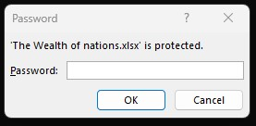
This popup window will come every time opening the file. This is the data can be secured and can only be shared to trusted authority.

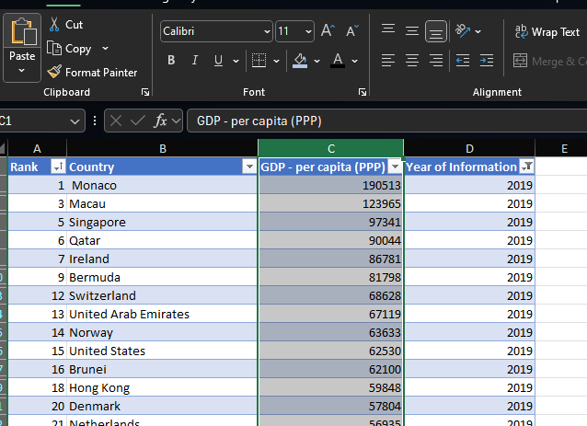

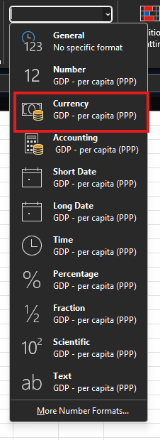
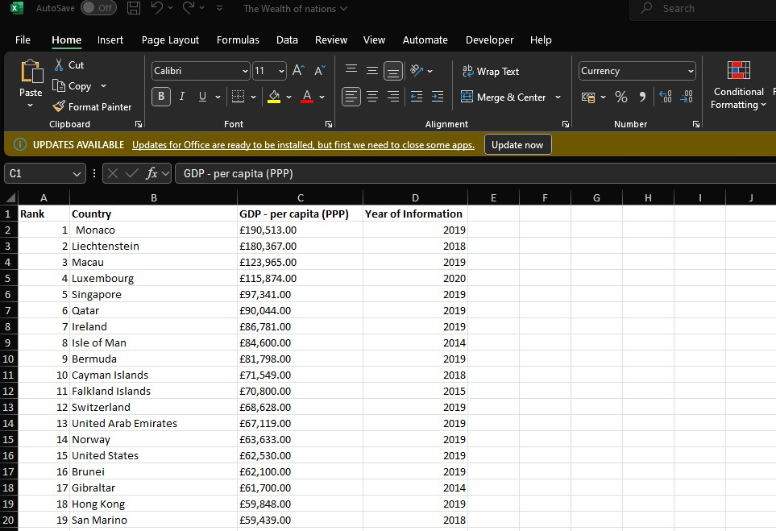
In this image I have changed the dollar sign in Column C to British Pound. To do so, I have selected the column. Then selected the format cells option from Home tab. Selected the currency and symbol of British Pound.

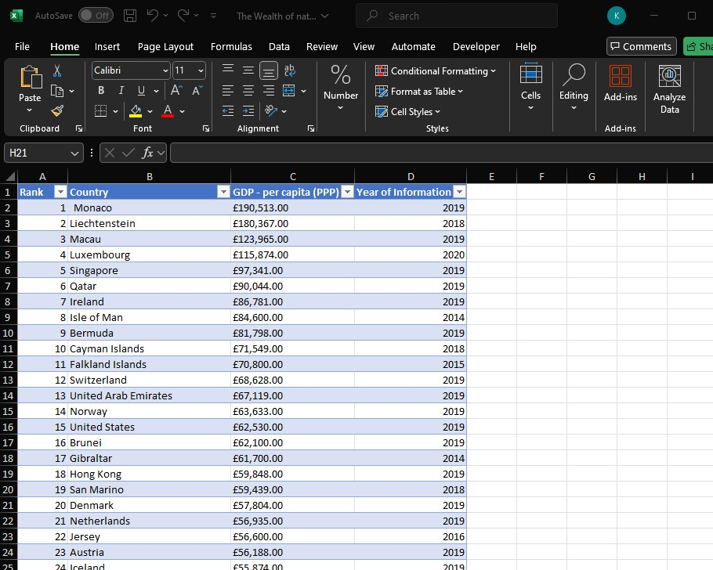
In this image I have turned the GDP page into a table by selecting cell A1:D229

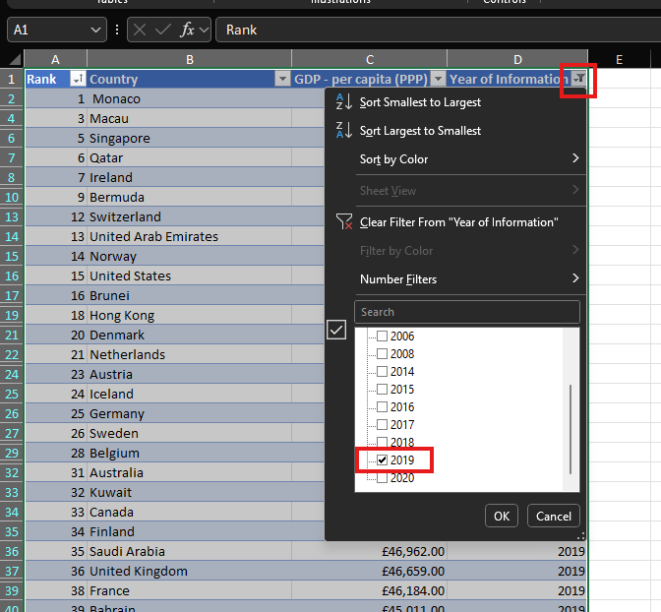

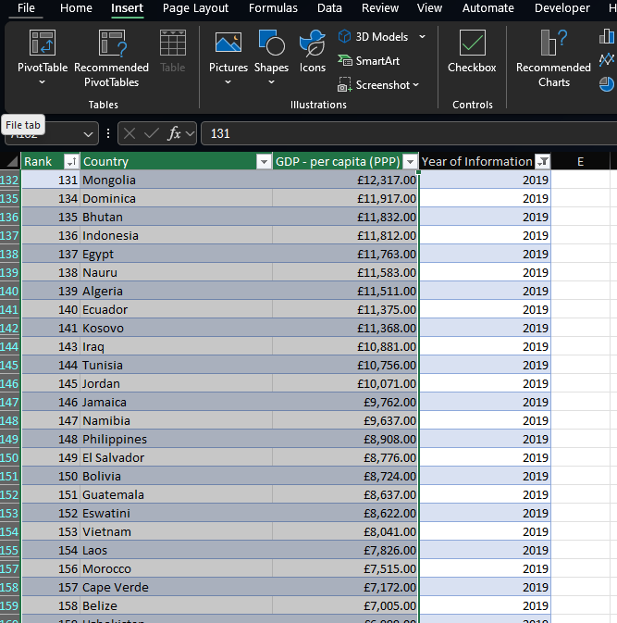

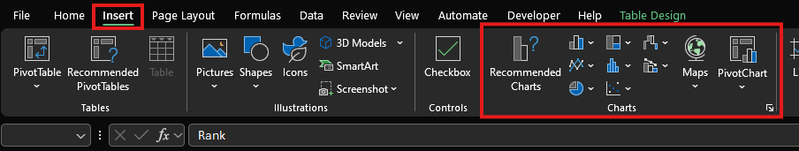

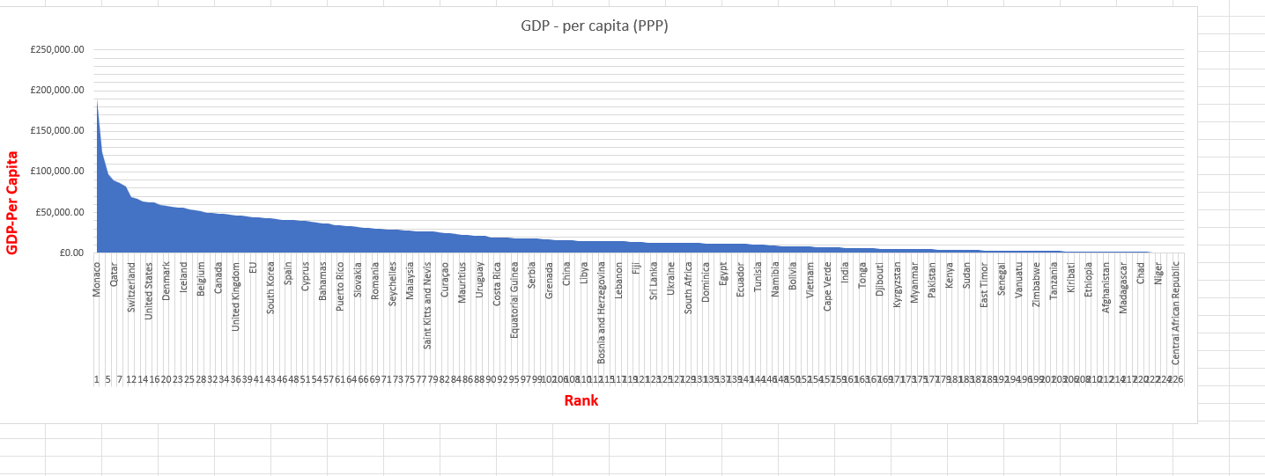

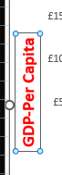

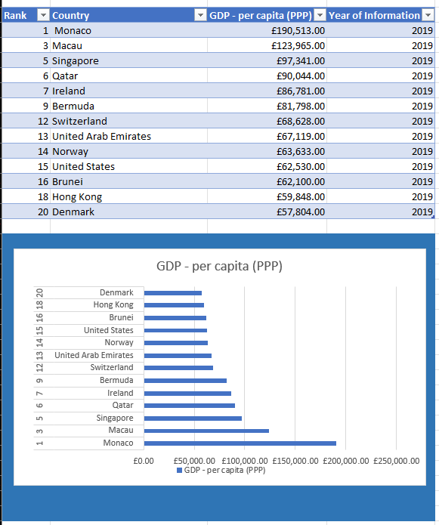

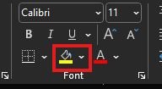

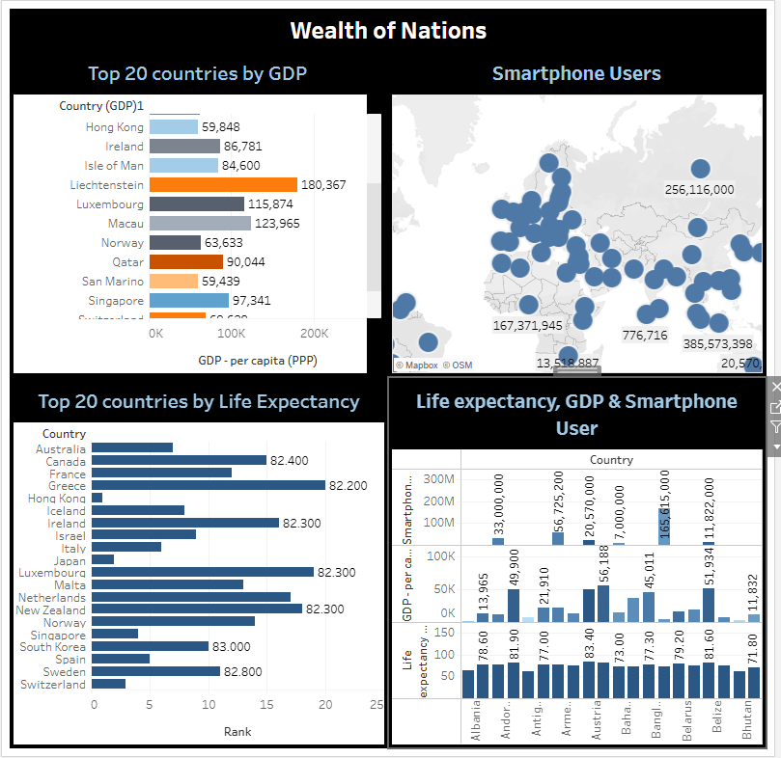

tableau assignment | Tableau Public

